- Read through the interactive (~15 -20 minutes).
  - https://www.scientificamerican.com/interactive/inside-the-coronavirus/

- Watch the video (~6 minutes).
  - https://www.scientificamerican.com/video/a-visual-guide-to-the-new-coronavirus-variants1/

- Register for a Posit Cloud account (~5 minutes).
  - Go to the Posit Cloud site (https://posit.cloud/)
  - Click “Get Started”
  - Select “Cloud Free” and “Sign Up”
    - Note: Do not sign up for the paid “Student” version. You do not need this version.
  - Enter your information or sign up with one of the other services listed (ex. Google, GitHub)
  - Verify your email by following the instructions on the page and in the message sent to you by Posit Cloud.
  - Your Posit Cloud Workspace should now automatically open. From your Posit Cloud Workspace. Click “New Project” and select “New RStudio Project” from the dropdown.

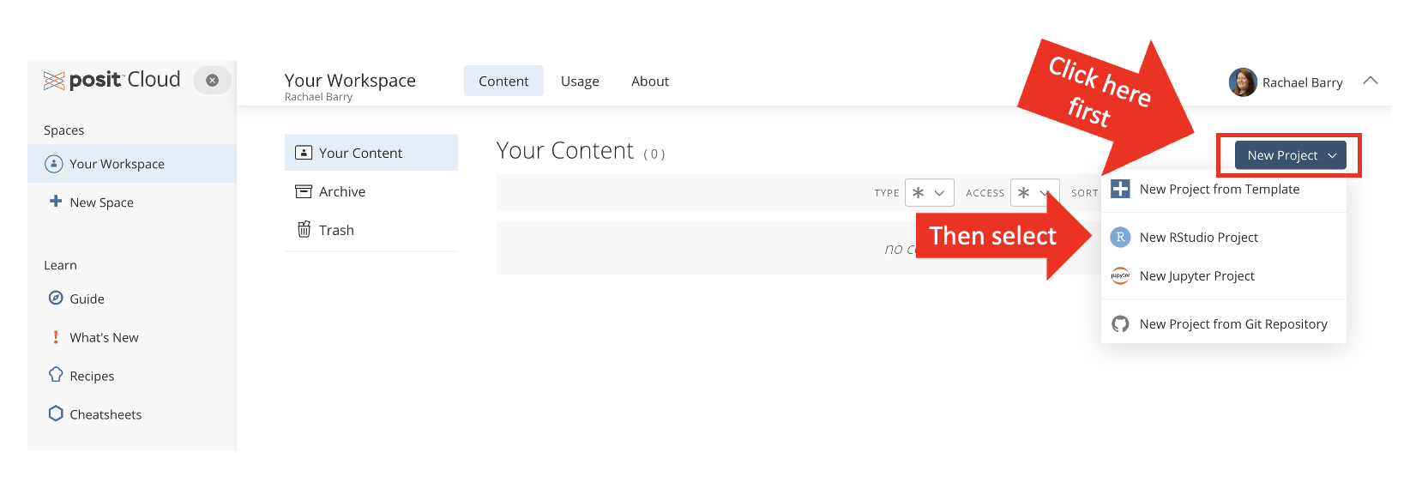

  - At the top of the workspace that appears, rename your project “Week 5 lab”. Take a screenshot of your workspace (including your username information) and upload it to Canvas to get credit for the pre-lab activity.

